1. 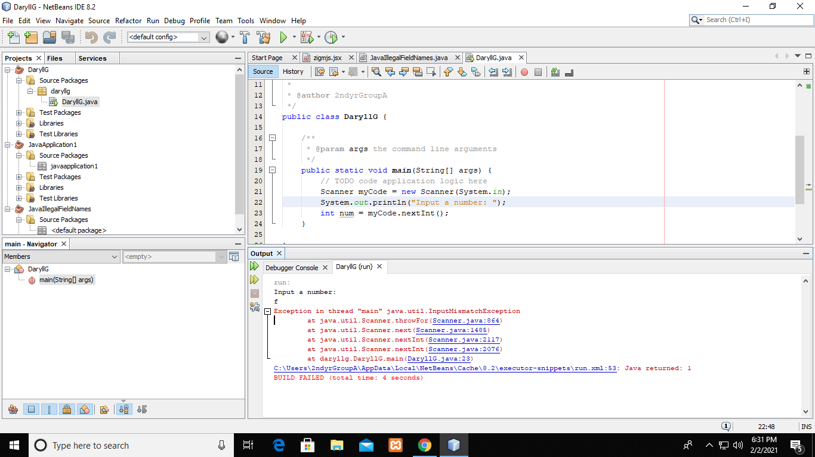Error occurs when the user input any letter instead of a number.
2. Uncompilable source code - incompatible types: int cannot be converted to java.lang.String

